TO BE PUBLISHED ON FRIDAY 19 NOVEMBER 2021

**#GiftThePlanet: The staggering impact of**   
**gifting donations to our Action Fund**

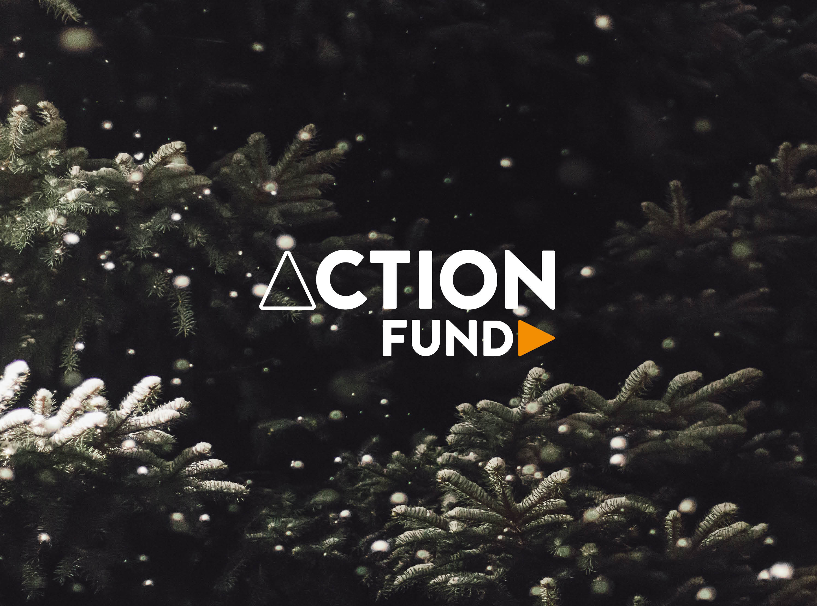

*From anti-fire kit to pressing land purchases or conservation programmes for vulnerable birds, our Action Fund supports the most urgent projects every year – and by gifting donations to your loved ones, you can make them part of future conservation success stories. Credit: Luke Hodde on Unsplash*

**Imagine there was a world where nature could be protected from the unexpected; a world where conservationists had resources ready to intervene whenever urgent action is needed. No need to imagine – that world is very possible, and you could help bring it about this year by donating to our Action Fund as a gift to your loved ones.**

In a world of ever-changing threats, the funds sitting in our [Action Fund](https://www.worldlandtrust.org/appeals/action-fund/) mean our partners are ready to spring into action when the situation calls for it: funding pressing land purchases, securing anti-fire kit and training and bringing in rangers to keep endangered species safe.   
  
Would you like to make your loved ones part of the next Action Fund conservation success story? Today you can, and we wanted to show you the impact you could be making by gifting donations to our programme – click on the map below to hear about the breakthroughs Action Fund supporters delivered during 2021.

**ACTION FUND: THE IMPACT OF GIFTING DONATIONS TO URGENT PROJECTS**  
Click on the image to discover Action Fund’s breakthroughs in 2021  
  
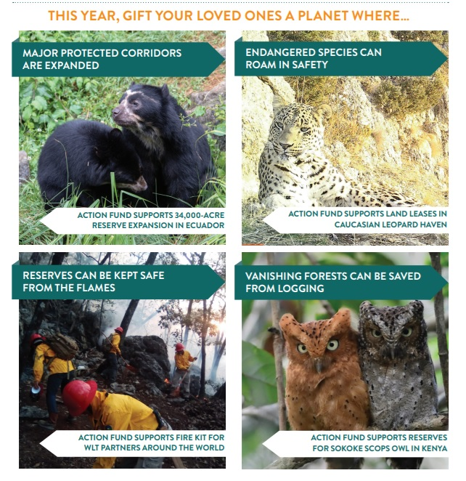  
  
-----------------------------------------------------------------------------------------

**Your friends and family can be part of the next Action Fund breakthrough**   
  
**Whatever threats our partners’ reserves face in 2022, with our Action Fund it will never be too late for nature – and here is where WLT supporters like you come in.**   
  
**If you were inspired by these conservation milestones achieved by Action Fund supporters in recent months, know this: through gift donations, your family and friends can play a part in the next victory.**   
  
**Head on to our** [**Gifts webpage**](https://www.worldlandtrust.org/get-involved/gifts/) **or check out our Donation Form to find out how to gift an Action Fund donation – the ultimate present for these holidays!**

**Major protected corridors are expanded**

(Image: AF supports 34,000 acre reserve expansion in Ecuador)

After four years of hard work by our partner [Naturaleza y Cultura Ecuador](https://www.worldlandtrust.org/who-we-are-2/partners/ncecuador/) (NCE), the Santiago Municipal Reserve was [officially declared this year](https://www.worldlandtrust.org/news/2021/03/endangered-eagle-corridor-ecuador/) – a link between two national parks in Ecuador and an expansion of vitally important habitat for endangered species, funded in part by donations to our Action Fund alongside a coalition of international partners.

**Endangered species can roam in safety**

(Image: AF supports land leases in Caucasian Leopard haven)

Supporters of our Action Fund allow our partner [Foundation for the Preservation of Wildlife and Cultural Assets](https://www.worldlandtrust.org/who-we-are-2/partners/fpwc/) (FPWC) to lease [Caucasus Wildlife Refuge](https://www.worldlandtrust.org/what-we-do/where-we-work/armenia/) (CWR) land from local communities - protecting a wildlife haven in a region that is one of the world’s lesser-known biodiversity hotspots. This year[, a new female Caucasian Leopard was spotted in the refuge](https://www.worldlandtrust.org/news/2021/10/armenia-caucasian-leopard-returns/), symbolising that this protected land remains a safe place for the Endangered big cat subspecies.

**Reserves can be kept safe from the flames**

(Image: AF supports fire kit for WLT partners around the world)

Donations to our Action Fund supports efforts from our partners to plan and prepare for the fire season and protect the critical reserves they manage. Not only do your donations enable us to support our partners to respond to the unexpected, straightaway, but they the rangers that play a vital role in monitoring the reserves. Through a combination of knowledge, regular patrols and community engagement, they are pivotal to taking action when these threats begin.

**Vanishing forests can be saved from logging**

(Image: AF supports reserves for Sokoke scops owls in Kenya)

Action Fund donations help protect Dakatcha Woodland along Kenya’s coast – a Key Biodiversity Area (KBA) and Important Bird Area (IBA) that is under threat from illegal charcoal production, uncontrolled farming and deforestation. These woodlands are home to one of the world’s smallest owls, the Endangered [Sokoke Scops Owls](https://www.worldlandtrust.org/species/birds/sokoke-scops-owl/). Supporters of our Action Fund help our partner [Nature Kenya](https://www.worldlandtrust.org/who-we-are-2/partners/nature-kenya/) to protect these territorial birds that roost in pairs in the canopy and come in two colours – grey and reddish brown.

**The home of Extinction facing species is saved**

(Image: AF supports purchases of Muriqui habitat in Brazil)

Brazil’s Atlantic Forest has lost 93% of its original cover but our partner [REGUA](https://www.worldlandtrust.org/who-we-are-2/partners/regua/) is fighting back with help from Action Fund supporters. This is one of the most important biogeographical regions in the Neotropics, with some 20,000 species of plants, 260+ mammals, over 300 species of reptile, nearly 500 species of amphibian and close to 1000 species of birds – it is not too late to give a better future to this magnificent wildlife haven.

**The illegal wildlife trade is kept away from habitats**

(Image: AF supports purchases of wildcat habitat in Colombia

A new [land purchase of 302 acres (122 hectares)](https://www.worldlandtrust.org/news/2021/01/guanacas-wildcats-brushfinch/) has connected Colombian cloud forests that are home to Ocelot, Oncilla, and the Antioquia Brushfinch, a Critically Endangered bird once known only from museum specimens. The expansion of the Guanacas Reserve to an incredible 1,700 acres (687 hectares) in the Colombian Andes was backed by our Action Fund supporters and made possible by the foresight, knowledge and hard work of our partner [Fundación Guanacas Bosques de Niebla](https://www.worldlandtrust.org/who-we-are-2/partners/fundacion-guanacas/).

**Vulnerable birds can raise a new generation**

(Image: AF supports Sarus Crane conservation project in India)

<https://www.worldlandtrust.org/news/2021/09/wtis-elephant-corridors/>

Our Action Fund supporters help fund the [Wildlife Trust of India’s](https://www.worldlandtrust.org/who-we-are-2/partners/wildlife-trust-india/) (WTI) [Sarus Crane](https://www.worldlandtrust.org/species/birds/sarus-crane/) Wetland Project – an extremely important plan to boost populations of this magnificent species. Standing at 6 feet, Sarus Cranes are the world’s tallest flying bird – yet the destruction of their habitat has pushed this species to use sub-optimal habitat for breeding.

**The life of Africa gets new champions to protect it**

(Image: AF supports rangers and anti-fire work in Zambia)

Set within central [Zambia](https://www.worldlandtrust.org/what-we-do/where-we-work/zambia/), Kasanka National Park is extremely vulnerable to fires, and the hot, windy days from August through to October can often make them impossible to control. Supporters of our Action Fund help our partner [Kasanka Trust](https://www.worldlandtrust.org/who-we-are-2/partners/kasanka-trust/) to prevent and control fire outbreaks in this wildlife sanctuary.

**Your friends and family can be part of the next Action Fund breakthrough**

**Whatever threats our partners’ reserves face in 2022, with our Action Fund it will never be too late for nature – and here is where WLT supporters like you come in. If you were inspired by these conservation milestones achieved by Action Fund supporters in recent months, know this: through gift donations, your family and friends can play a part in the next victory.**

[**Click here**](http://worldlandtrust.org/get-involved/gifts/) **to gift an Action Fund donation – the ultimate present for the holidays!**